ECPI University Rafat Khandaker

CIS_126 07/26/18

Unit 1 Graded Assignment 1

1) Please explain what is happening with each line of coding syntax in the programming shell template up above?

#include <stdio.h>

*“This part of the program is allowing us to use the standard stdio.h library that is referenced in the stdio.h file. This library is included and used in all C programming.”*

2) What is meant by declaring a variable? What is a data type and why do we assign one to a variable? What are some great variable naming conventions? What can we not include in a variable name?

*Declaring a variable type allows us to specify the type of data we chose to store in the computer’s memory & also allocates the maximum amount of space this memory will use.*

3) What is the difference between the scanf() and printf() functions? What is the syntax that is needed for both types of statements? Please provide a coding sample of each.

*Both scanf() & printf() are standard functions in C’s core library. Both functions take at least 1 parameter, which Is a string value. Scanf’s function will take in at least 2 parameters, a string & generic data type to store a user’s* ***input*** *value into a variable. The printf function will take at least 1 string value &/or multiple generic object variables to compile an* ***output*** *string buffer to user console window.*

*In this example,* ***printf()*** *statement has executed & printed a prompt onto the console. The breakpoint indicates that the program is waiting for a user input before continuing.*

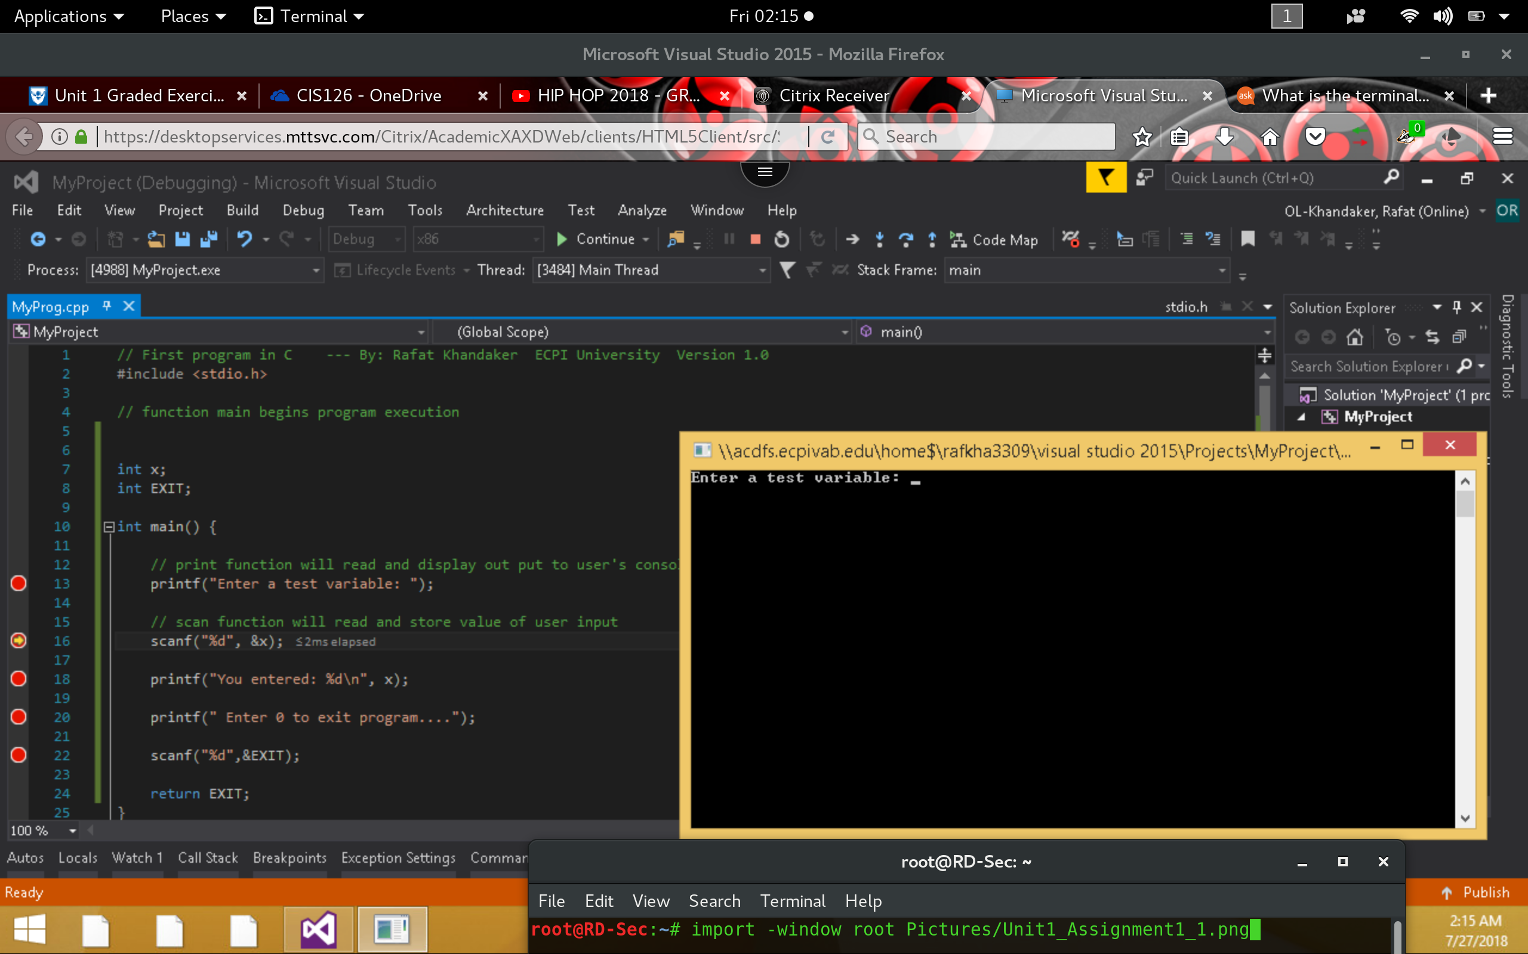

*In this example,* ***scanf()*** *statement has accepted user input and stored the variable into memory & executed the next command. The* ***printf()*** *statement has executed & displayed user’s input onto the console. The breakpoint is now on the last* ***scanf()*** *function, again waiting for user input to terminate the program.*

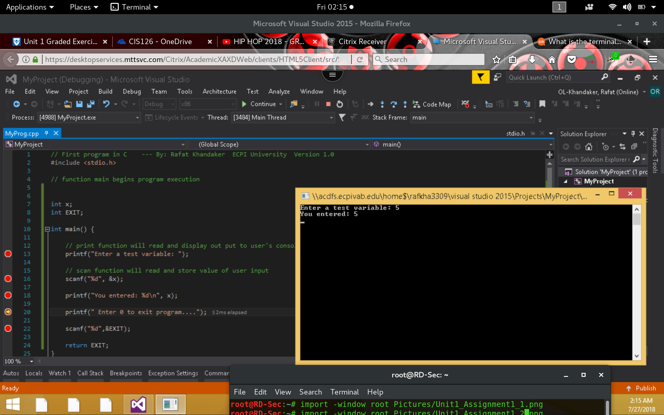

*Continue and finish program execution. ..*

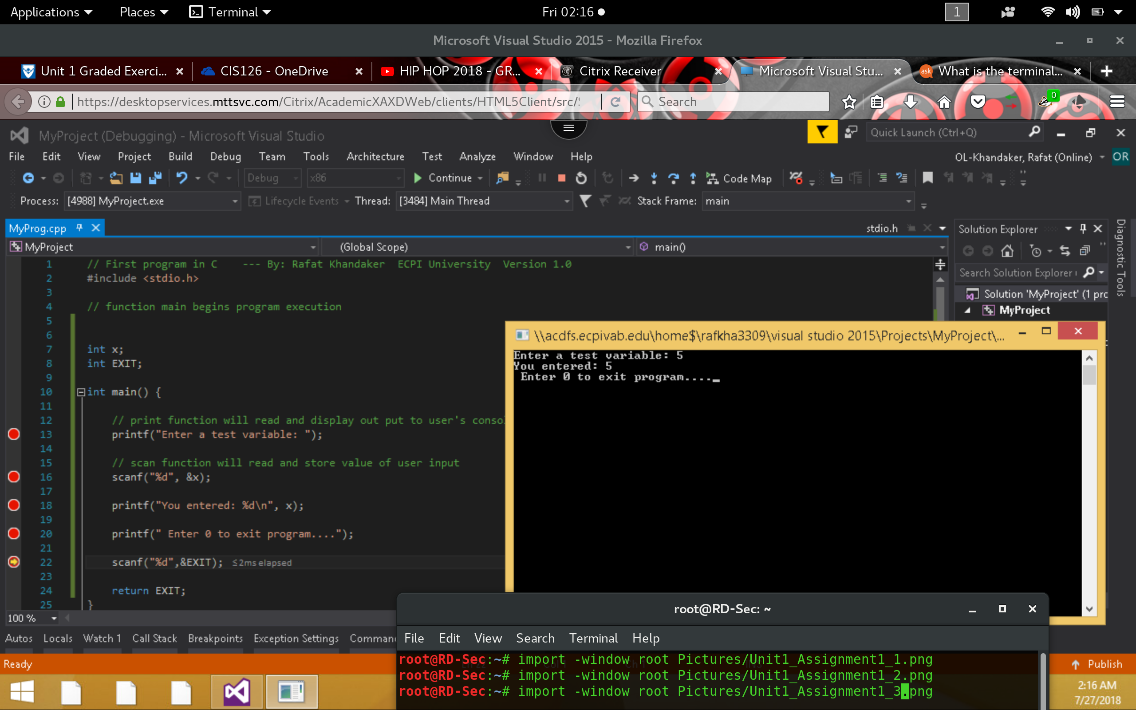

4) What is the difference between a decisional statement & a looping structure? Which one includes increment or decrement operators & what is their function?

*Decisional & Looping operations are both used in programming to maintain “Control Flow,” of a program. Usually we use “Decisional Operations,” to execute a program block based on a Boolean condition; IF & Else Statements are considered “Decisional Operations.” Looping structure are used to repeat an execution task in a program in order to overcome redundancy. Looping logic usually use a Boolean condition, based on a counter, which can include incrementing or decrementing counters. Looping logic contain counters when we have a defined number of times we would like to execute this loop, by default looping logics are based on a Boolean condition & will execute as long as the condition is true. “While,” “For,” & “Do-While,” are considered looping structures.*

5) Please provide a real world example of both a decisional statement and a looping structure and include a coding snippet with your written examples.

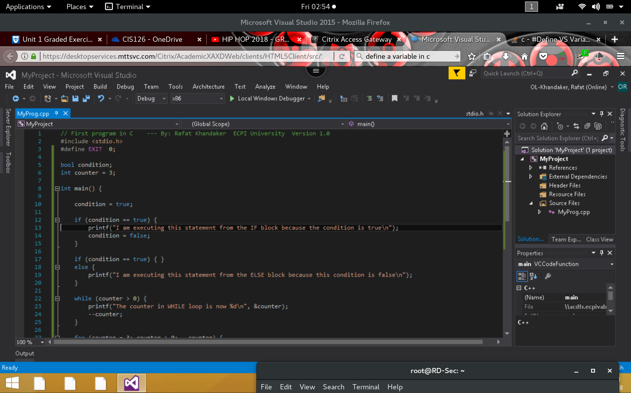

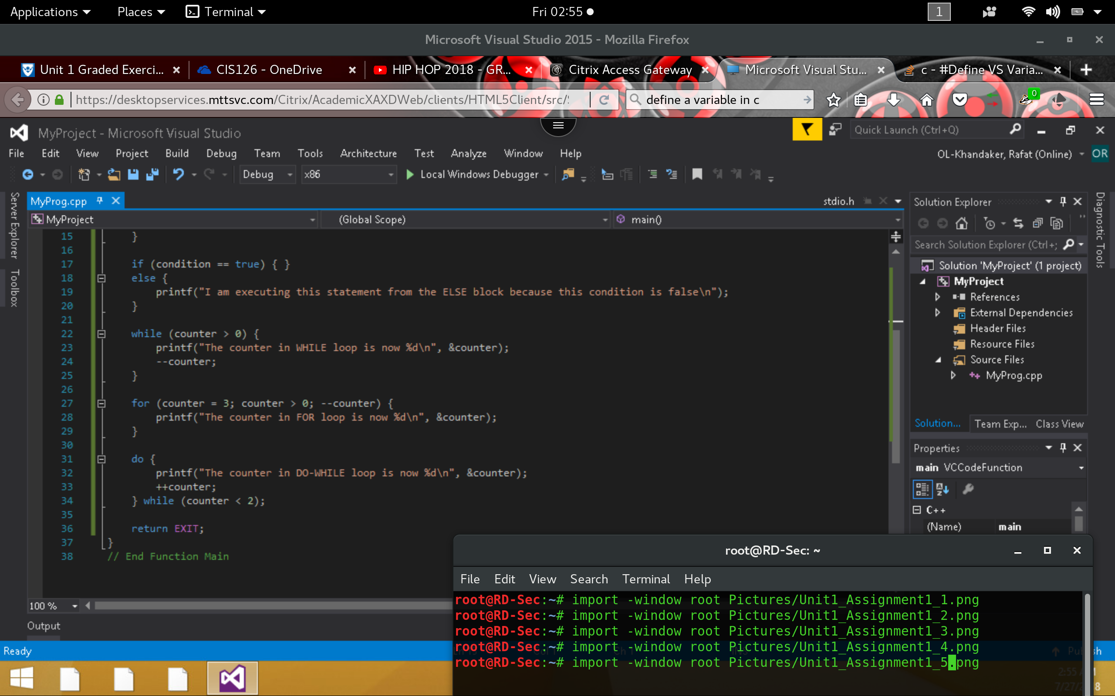

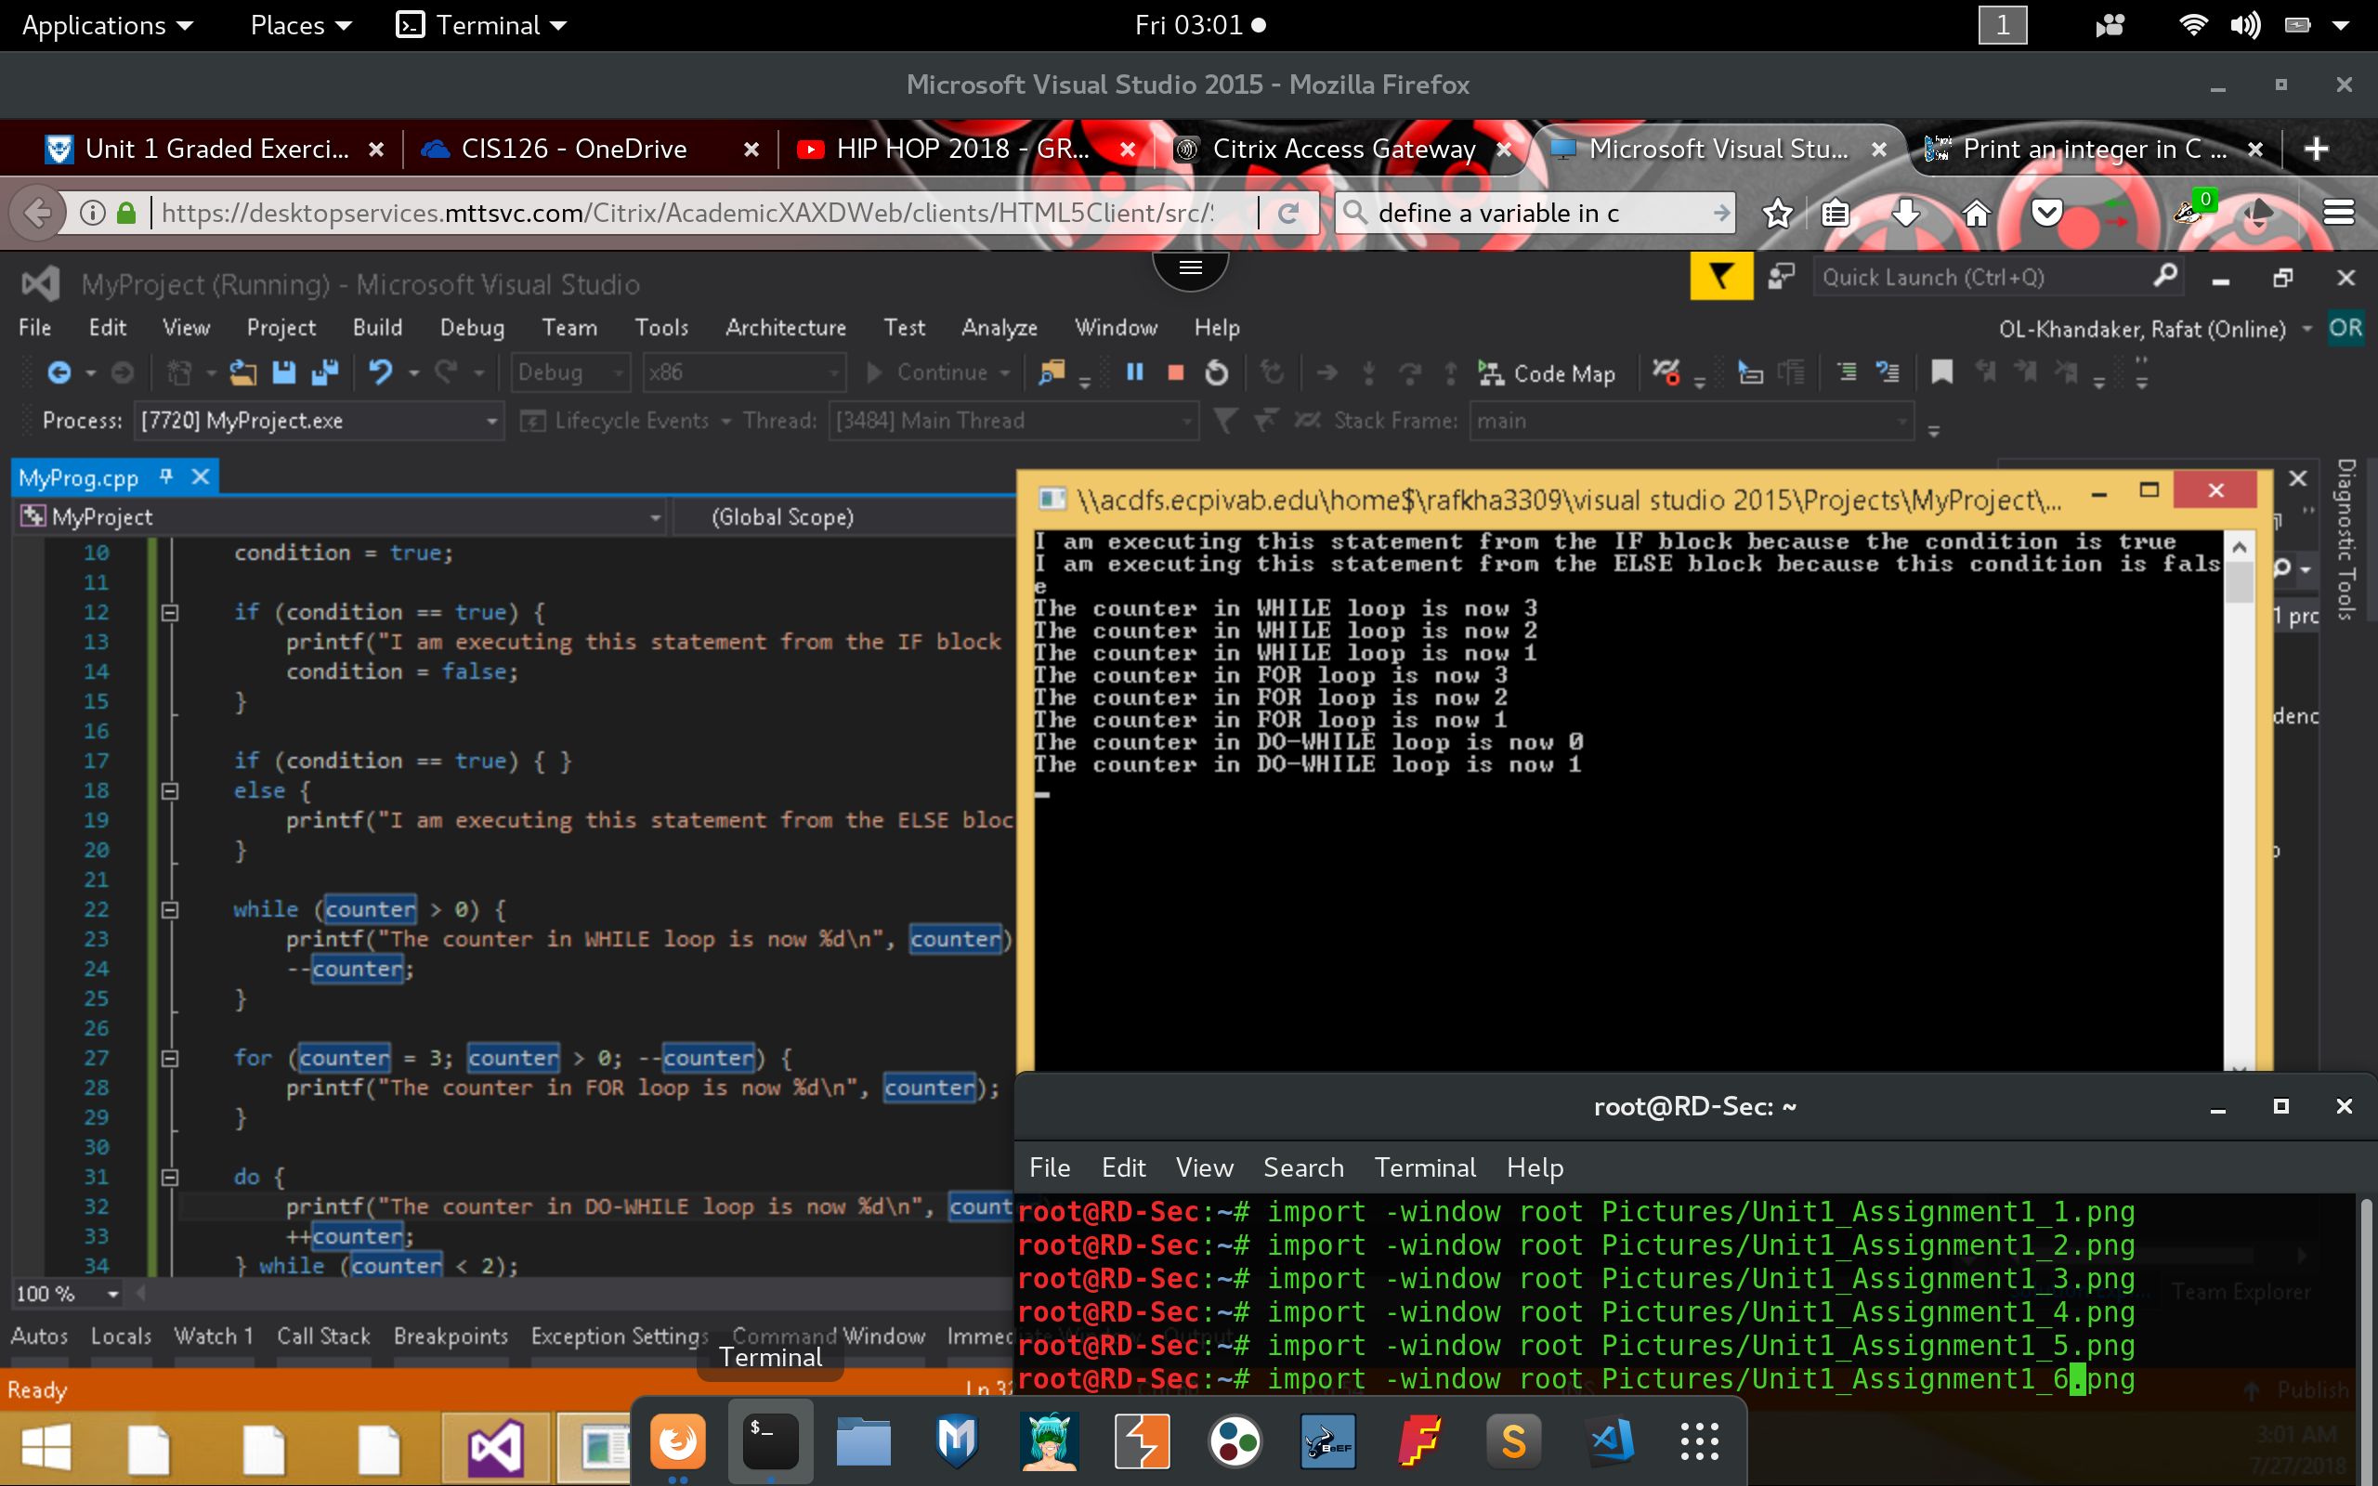

PART 2

1) Execute the following code and identify the errors in the program. Debug the program and provide the correct version of the code.

*In here, we have to scan the number with “&” to store the variable.*

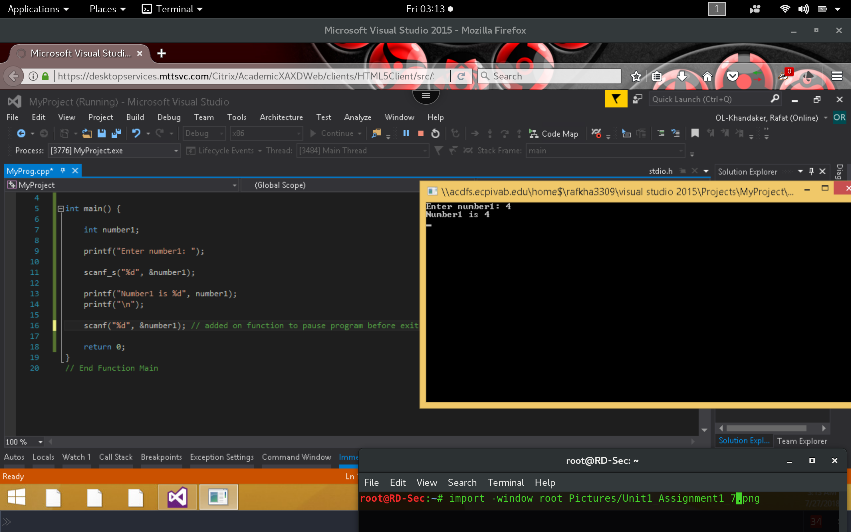

2) Execute the following code & identify the errors in the program. Debug the program & provide the correct version of the code. Note: Be sure to check the output screen to see if the corrected values are displayed according to the output statements.

*Remove “&” from printf statements. Insert “%d” , variable in the printf statement to show radius.*

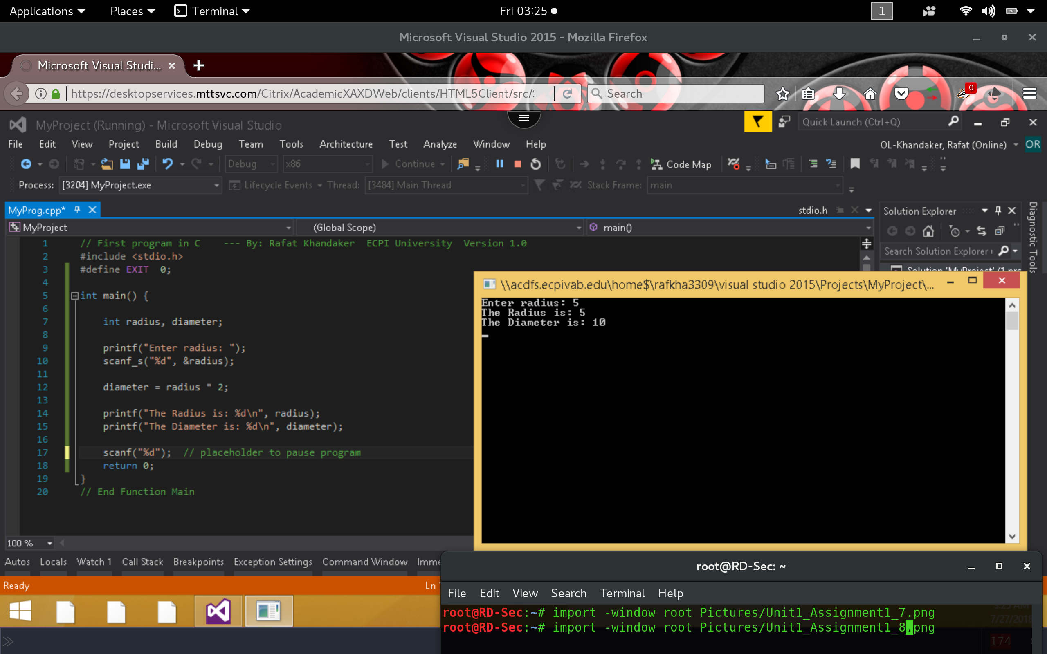

3) Execute the following code & identify the errors in the program. Debug the program & provide the correct version of the code.

*Radius was not scanned to a variable*

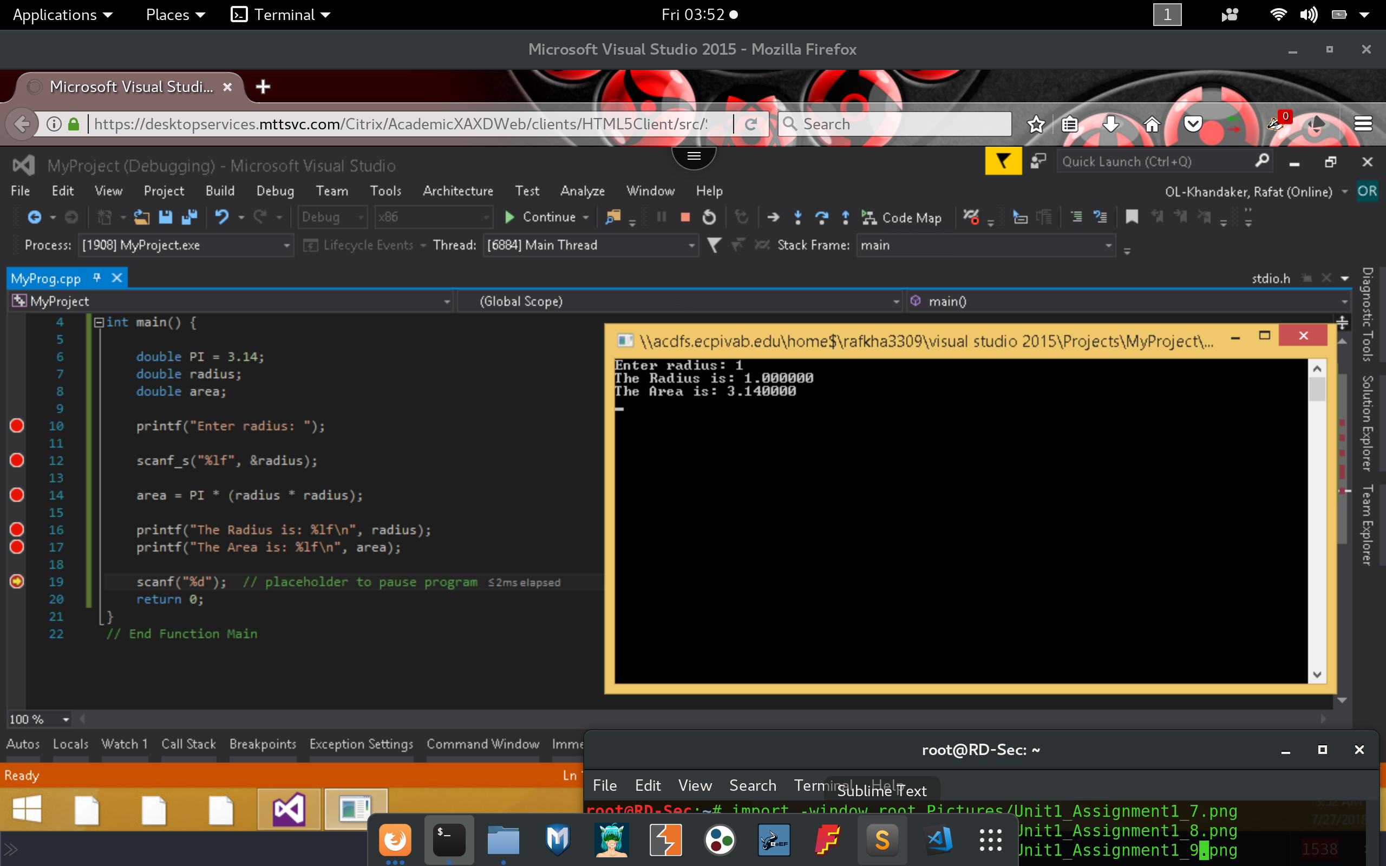

4) Execute the following code and identify the errors in the program. Debug the program and provide the correct version of the code.

*Remove “;” from the if statement*

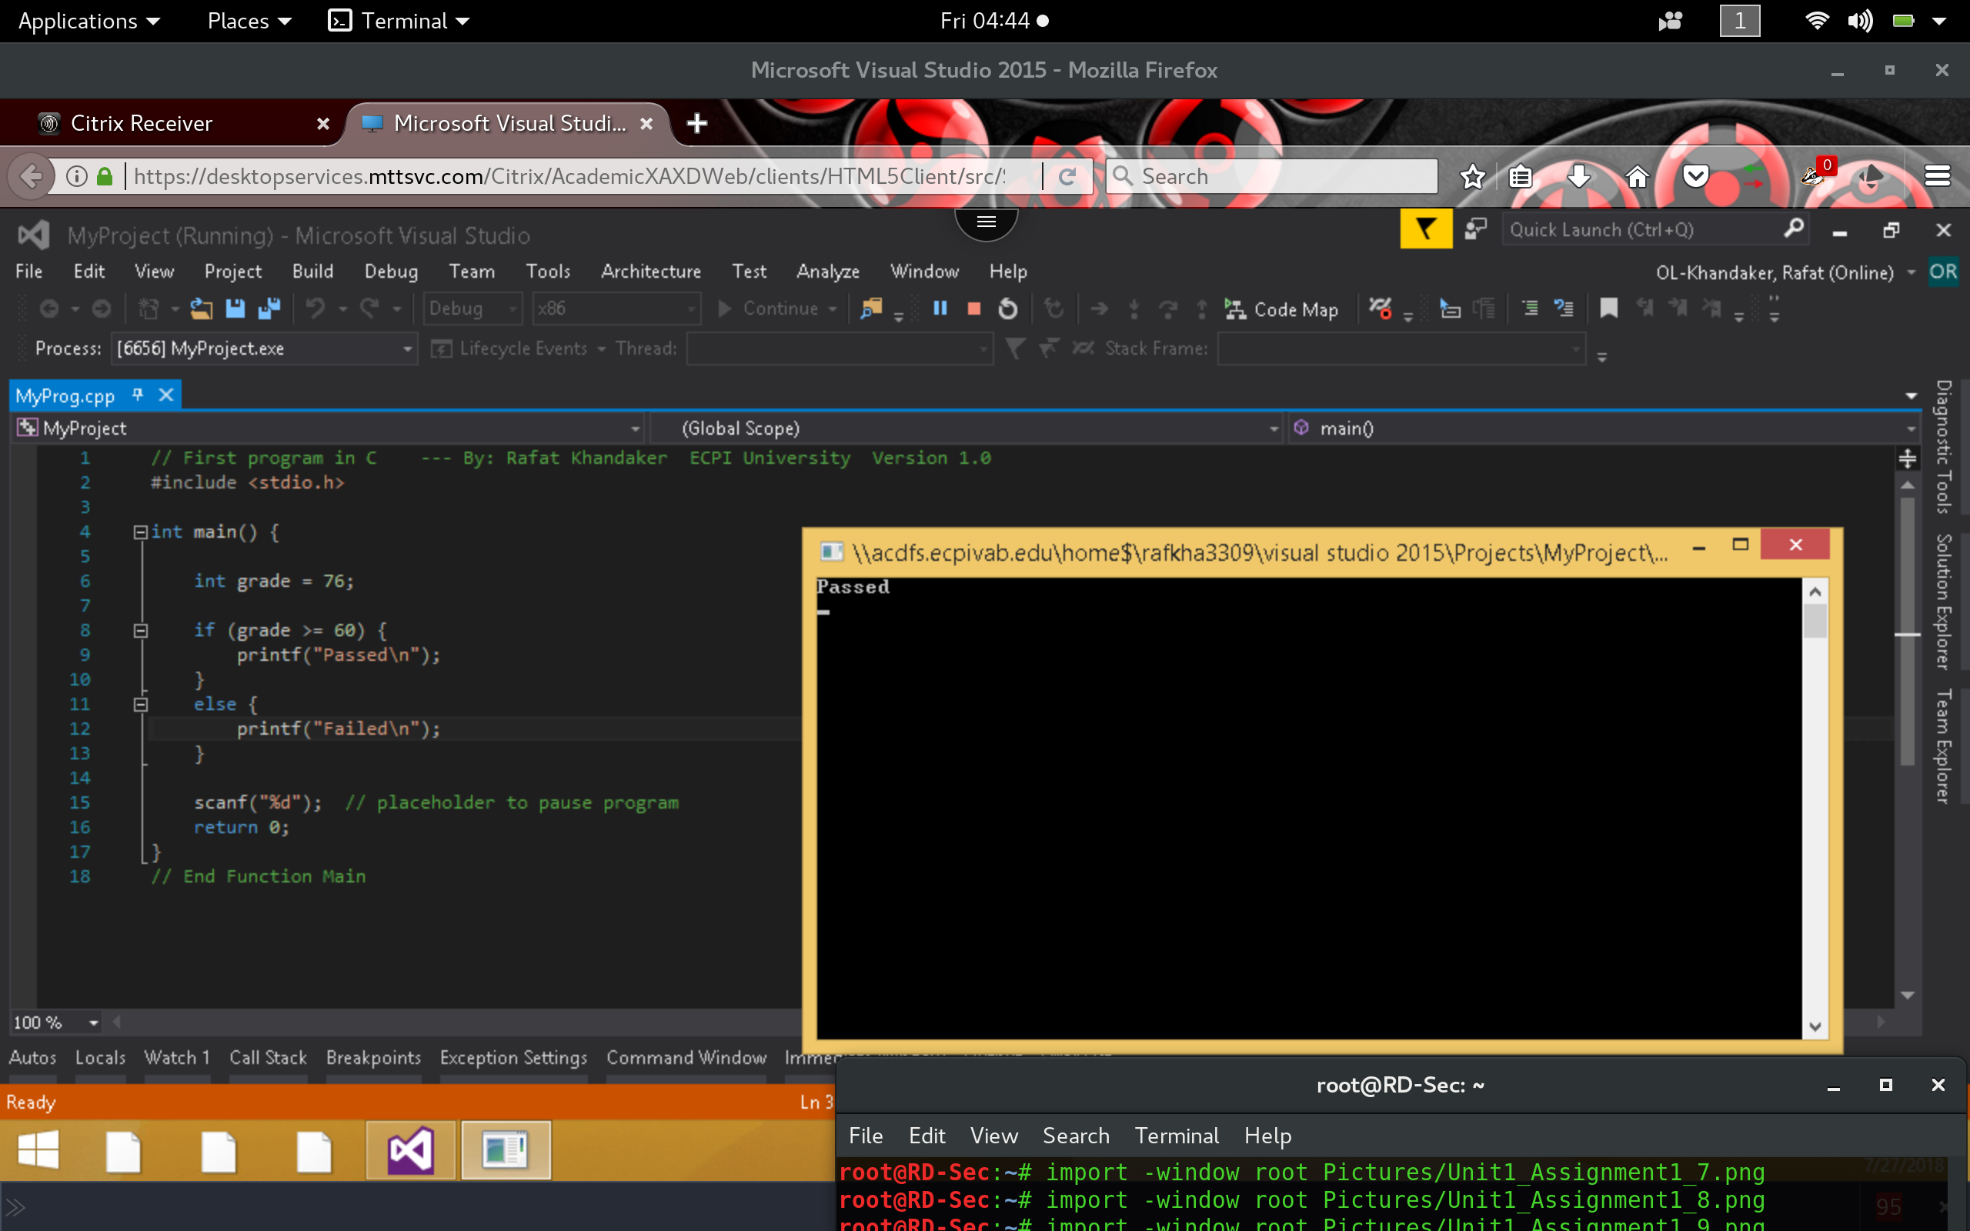

5) Execute the following code & identify the errors in the program. Debug the program & provide the correct version of the code. Note: There are two errors in the snippet bellow.

*Infinite loop, in here we need to decrement the count value.*

